*[](http://www.google.co.uk/url?sa=i&rct=j&q=&esrc=s&source=images&cd=&cad=rja&uact=8&ved=0CAcQjRxqFQoTCJKH68CE08cCFaeh2wodxngCxg&url=http://www.beaulyprimary.co.uk/?p=2507&ei=BSLkVdLwB6fD7gbG8YmwDA&psig=AFQjCNH7TlKdEwA2tfIf7J-qF1R_6m5CLA&ust=1441100507322216)Dear Parents and Guardians,*

**Punctuality- Class begins at 9.10 am each day. Please arrive to school punctually.**

**We encourage all pupils to attend school every day. If your child is off school for any reason please contact the school either through Seesaw or via the school office**

**ATTENDANCE**

Going to school regularly is important for your child's future. It is essential to maintain a pattern of good attendance throughout their school career.

**Holidays**

**AMILY HOLIDAYS** – You can demonstrate your commitment to your child’s education by

You can demonstrate your commitment to your child’s education by not taking holidays during term time. We can not authorise holidays taken during term time and they are recorded on the system as un-authorised absences.

**This is DENI Policy and the Education Welfare Officer follows up on this. Thank you for your co-operation with this matter.**

Newsletter

*I hope you have all had a restful summer break and we are delighted to welcome all our pupils back to school for this new academic year. I would especially like to welcome our new Primary One pupils. I wish our “leaver’s class of 23” the very best of luck and success as they move into post primary education. I look forward to leading such a wonderful school into 2023/24. I hope that we have another happy and successful year at St. Columba’s.*

*We are looking forward to a very exciting new year with lots of wonderful opportunities for our pupils. May this be a happy, calm, positive, fulfilling and successful year for all of our families. Mrs P Mc Alister*

**ST COLUMBA’S P S - SCHOOL CLOSURES 2023-24**

TERM 1 – 31 August to 22 December 2023

31 August 2023 ……………………………… School re-opens for term 1a.

(School finishes at 12 noon. NO BUS OR SCHOOL MEALS)

30 Oct to 3 Nov 2023 (incl)………….. Hallowe’en Holidays

6 November 2023 …………………………. School re-opens for term 1b

22 December 2023 …………………………School closes at 11.00am

25 Dec 23 to 3 Jan 2024 (incl) ……..Christmas Holidays

TERM 2 – 4 January to 28 March 2024

4 January 2024 ………………………………. School re-opens for term 2a

12 to 16 Feb 2024 (incl) ………………… Mid term break

19 Feb 2024 …………………………………….. School re-opens for term 2b

18 March 2024 ………………………………… School closed (St Patrick’s Day)

28 March 2024 ……………………………….. School closes at 11.00am

29 March to 5 April 2024 (incl) ……. Easter Holidays

TERM 3 – 8 April to 28 June 2024

8 April 2024 …………………………………….. School re-opens for Term 3a

6 and 7 May 2024 …………………………… School closed (May Day)

27 to 31 May 2024(incl) ………………… Mid term break

3 June 2024 …………………………………….. School re-opens term 3b

28 June 2024 ………………………………….. School closes at 11.00am for summer holidays

(Above dates include 5 Baker Days and 5 Staff Development Days for Teachers)

***Other dates***

Flu Vaccine- 27th October

PT meetings - 14th and 15th November- - School will close early on these three days to facilitate Parents Meetings P1/P2 @ 12.10 P3/P4 @ 12.20 P5/P6/P7 @12.30

**Curriculum Meeting**

• We also hope to host curriculum meetings in the month of September. This will give you the opportunity to see your child’s classroom and meet the teacher. The class teacher will give you an insight into the teaching and learning content in that class. You will also find out about routines and other important class information. The parent and school partnership is so important as you are the most important influence in a child’s life. Your child’s educational journey can only be fully effective if there is strong partnership between parent, children and school.

• **P1 meeting- 27th September @7pm**

• **P2 meeting- 19th September @7pm**

• **P3 meeting 20th September @7pm**

• **P4 meeting 20th September @7pm**

• **P5 meeting 28thSeptember @7pm**

• **P6 meeting 21st September @7pm**

• **P7 meeting 13th September @6:30 **

**Please make sure you update your contact details**

**if they have changed. It is extremely important**

**that we have up to date contact details for all**

**Information update.**

**We are updating all information which we have on record for all our children for the new school year. If there have been any changes in any of the following please send this updated information into school.**

**Change of:**

* **Address**
* **Phone number**
* **New or change in medical condition**
* **Child minder contact details etc**
* **Any other change in circumstances.**

**MEDICAL CONDITIONS**

* If your child uses an inhaler, this should be sent in on the first day in a clearly labelled box. (Name, DOB and parent contact details) along with the care plan.
* If your child has sensitive skin condition and uses a soap prescribed by the doctor this should be clearly labelled before sending it into school.
* If you are concerned that your child has a medical condition that we are not already aware of, please contact the school so that we can update our records.

**Class teachers will be reviewing their Medical**

**Registers. Anyone with serious medical needs will**

**have already spoken to their class teacher.**

**Please make arrangements to meet to update medical**

**plans if you have not already done so. If your**

**child has developed symptoms over the summer,**

**School Uniform**

**LABELS**

**Please mark all belongings with your child’s name.**

**Remember if items are labelled we can return them to their owners easily.**

**We appreciate your cooperation in sending your children in their uniform to school each day. The PE uniform should be strictly observed as it reduces peer pressure to have the latest/most expensive gear.**

|  |  |
| --- | --- |
| **Non PE Days** | **PE Days** |
| * Maroon jumper with school logo * White polo shirt * Grey skirt/pinafore/trousers/ shorts for girls * Grey trousers/shorts for boys * Red summer dress for girls * Black, grey or white socks * Black shoes | On PE days, pupils should wear   * own choice of trainers * plain black jogging bottoms * plain white t-shirt/polo shirt     **Full school uniform should be worn daily except on P.E days. This included black shoes.** |

**CAR PARKING AT HOME TIME**

We would request that everyone shows respect for each other and follows our safety procedures in getting all children picked up safely. You will notice that there has been increased traffic congestion due to the close proximity of the building work.

Please drive to a designated parking lot, walk over to the footpath in front of the school. When the teacher sees you they will release your child/children.



Please do not block the gates or the zebra crossing or sit in the thoroughfare blocking others. It is vital that this message is relayed to babysitters/childminders/grandparents or anyone who may be collecting your children.

**Finish times**

P1 and P2 - 2pm

P3-P4 school -2.50pm,

P5-P7 is 3pm

(except Fridays when finish time is 2:45 for all pupils P3-P7)

[](https://www.bing.com/images/search?view=detailV2&ccid=yvkTBDND&id=2AE572D410BE03A11155EF412B41C2EF0C3990FF&thid=OIP.yvkTBDNDlEvHAjcQNXrbjwHaHa&mediaurl=https://img.cdn.schooljotter2.com/sampled/11483070/900/0/nocrop/&exph=900&expw=900&q=child+protection&simid=608014269666427825&selectedIndex=2)**THE SAFEGUARDING TEAM**

Our safeguarding team works to keep everyone safe and happy. If you have any child protection concerns, please contact any of the team.

**Designated Teacher-**  Mrs Mc Elhatton

**Deputy Designated Teacher** – Mr Henry

**We are an allergy aware school**

**PLEASE DO NOT SEND ANY FOODS CONTAINING NUTS TO SCHOOL!**

**We also have children in our school who have an egg allergy. Staff will be very vigilant in trying to identify any foods containing eggs and taking necessary precautions.**



If you have a concern or a query, do not hesitate to contact me by **phone** on 028 295

If you have a concern or a query, do not hesitate to contact me by **phone** on 028 295

**We also welcome 3 new staff members to Team Straw**.

Mrs Mc Nicholl- classroom assistant

Miss A Kennedy- Primary 3 teacher

Mr C Gervin Primary 6 teacher

**HEALTHY EATING**

The Healthy Break-time Policy is part of a broader Heathy Eating Policy that has been agreed by the staff, governors, and pupils of the school. It aims to promote the dental health of the children by ensuring that they do not take sugar containing snacks and or drinks between meals during the school week. We value your support in helping us to carry out this important job.

Mid-morning breaks should consist of:

Fresh fruit or vegetables

A bread based snack with a sugar free filling.

A plain cracker or similar snack.

No cereal bars as they often contain chocolate or sugar coatings.

Water is the only drink permitted during mid-morning break. We encourage children to bring a reusable water bottle to school each day to allow them to drink water during class times.

Our new lunchtime policy is that there is NO MORE THAN ONE TREAT in pupil lunch boxes.

Dinners are £2.60 and can be paid weekly or daily. If possible we would ask that breaks are paid in advance at the start of the week. Toast 25p/Baguette 35p /

fruit 55p

**Dressing-Up**

There are regular fun events that are organized throughout the year to add to the fun element of school life whilst enriching the learning experiences of our children. There are a few of these that we ask children to dress-up for, but if they choose to wear their uniform that is perfectly fine.

Hallowe’en – 27th October wear Hallowe’en costumes

Christmas Jumper Day in Dec (TBC)

2nd March 2023- World Book Day (Dress up as your favourite character from a book)

16th March – “Green day” Wear something Green – St Patrick’s Day

There may be other events such as wear something red/wear a jersey etc. but this depends on the events of this year. We will give as much notice as we can.



**Stay and Play Club**.

This Club allows children in P1 and P2 to stay on at school between 2pm and 3pm with their friends, thus saving parents having to do multiple pick-ups. The children are supervised by our staff. This Club began on September 1st for our P2 children and will commence on 2nd October for P1 children.

The club cost is £2.50 per day. Please book your place by sending payment in a labelled envelope and specifying the requested days.

The Breakfast Club operates from 8:20-8:50 each morning. It provides a service for our parents and children get breakfast followed by games and a chat with friends. If you are interested in enrolling your child please contact the school.

Cost-£1.30 per day.

**CURRICULUM MEETINGS**

We also hope to host curriculum meetings in the month of September. This will give you the opportunity to meet the class teacher. The teacher will give you an insight into the teaching and learning content in that year group. You will also find out about routines and other important class information. The parent and school partnership is so important as you are the first and most important influence in your child’s life. Your child’s educational journey can only be fully effective if there is a strong partnership between parent, child, and school.

* **P1 meeting- 27th September @ 6:30 pm**
* **P2 meeting- 20th September @ 6:30 pm**
* **P3 meeting- 26th September @ 6:30 pm**
* **P4 meeting- 19th September @ 6:30 pm**
* **P5 meeting- 21st September @ 6:30 pm**
* **P6 meeting- 25th September @ 7:00 pm**
* **P7 meeting- 11th September @ 6:30 pm**

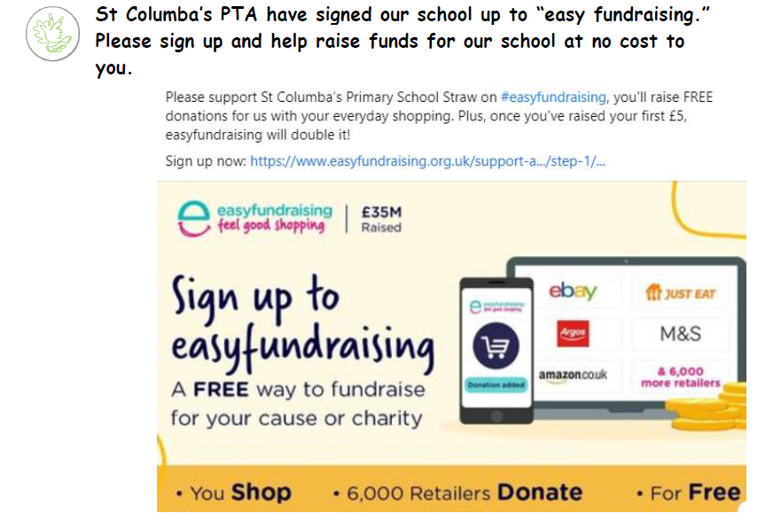

If you have a concern or a query, do not hesitate to contact me by **phone** on 028 295

If you have a concern or a query, do not hesitate to contact me by **phone** on 028 295

**Remember, our school PTA is always in need of more members.**

**If you would like to help us with fundraising and organising various events please contact the school.**





If you have a concern or a query, do not hesitate to contact me by **phone** on 028 295

If you have a concern or a query, do not hesitate to contact me by **phone** on 028 295

If you have a concern or a query, please contact the school at 02879628685.

You can also **email** the school

Stay connected to your child's **Seesaw Family app** for ongoing announcements.

Don’t forget to join our Facebook family and our **Twitter** page.

We post regularly on these platforms. We are also in the process of getting a new Website. This will be available to view soon. More news later.

Remember you can help to promote our school by responding and commenting positively on Face book and Twitter. We use Facebook and Twitter to announce upcoming events or share the success of recent activities. This helps to maintain a positive buzz about our school.

**Please become involved, if you like what you see comment and share.**

**I wish to remind applicants of Free School Meals**

**and Uniform Allowance of the 4-week processing**

**time for applications. If you submitted an**

**application before 31st July, your support will be**

**in place for the 1st September. If you applied**

**after 1st August, your support will not be in**

**place for 1st September, but you will be notified**

**when your application has been completely**